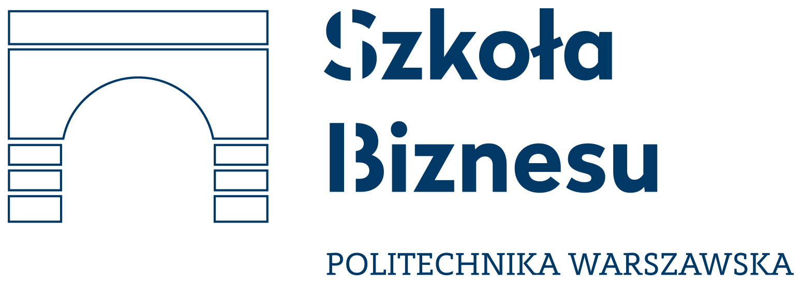
FREE PROJECT
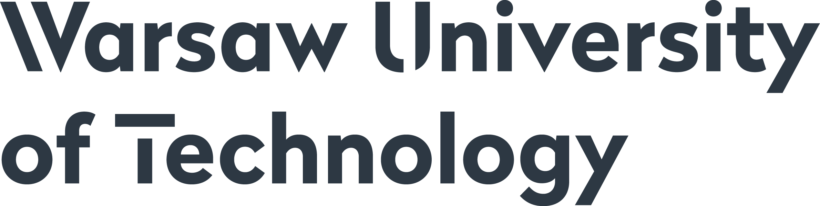

APPLICATION FORM
FREE BUSINESS CONSULTING PROJECT

Please fill it in and send by email to:
agnieszka.felczak@biznes.edu.pl

Deadline for submitting applications: 31 March 2018

Company Name | Industry/Main business
Postal address and phone | Website Address
Number of employees | Year of establishment
Suggested topic of the consultancy project:

Short description of the consultancy project:

Business Context:

Person responsible for the student group | Phone and email address
Do you allow the representatives of the competition to be in the group of students?

